Spatial Principal Component Analysis (sPCA) and Monte Carlo Test.

(a) | (b)
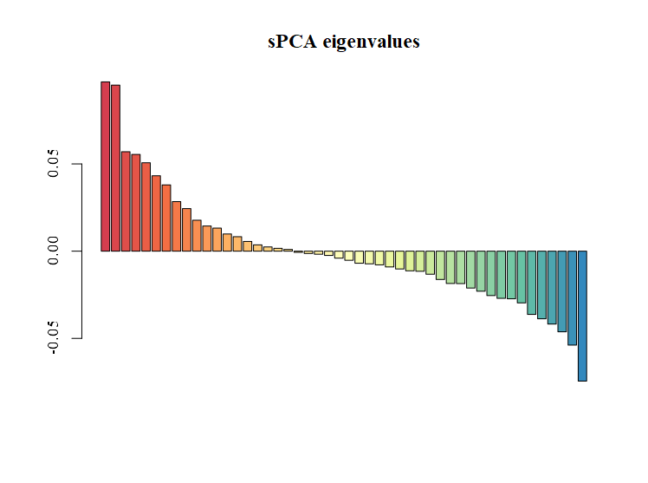 | 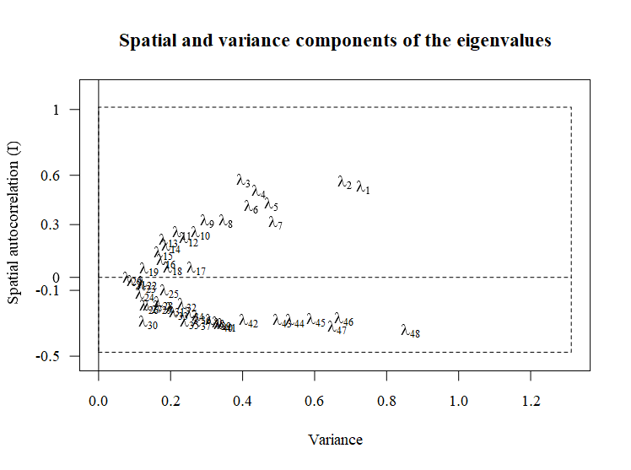
(c) | (d)
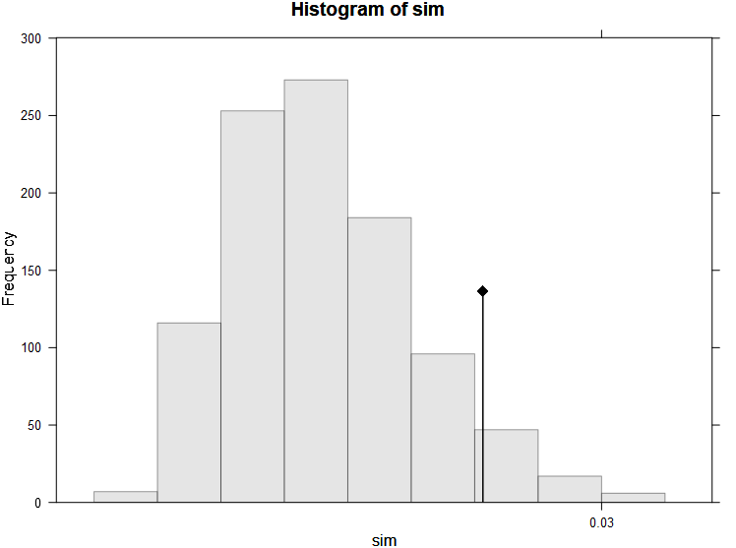 | 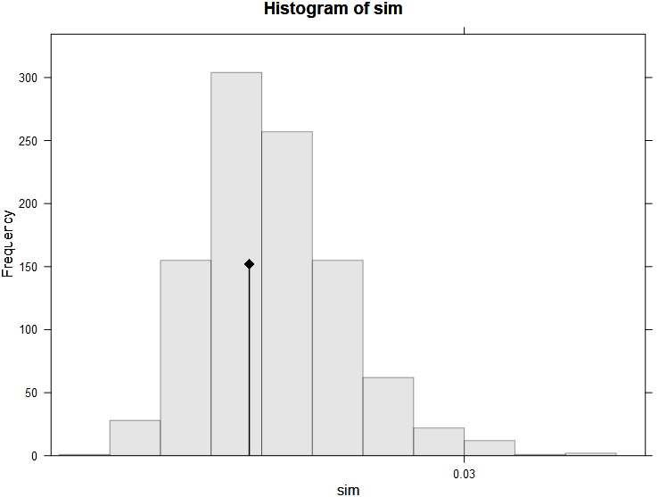
Results of spatial Principal Component Analysis (sPCA) based on nine microsatellite loci. (a) Positive eigenvalues (on the left color red) correspond to global structures, while (b) negative eigenvalues (on the right color blue) indicate local patterns. Figures (c) and (d) depict the results from the Monte Carlo test for global and local structure, respectively; the observed test statistics fall inside the simulated values and the null hypothesis of absence of spatial structure cannot be rejected.

Bayesian Information Criterion (BIC) used to identify the most likely number of gene pools in the Discriminant Analysis of Principal Components (DAPC)
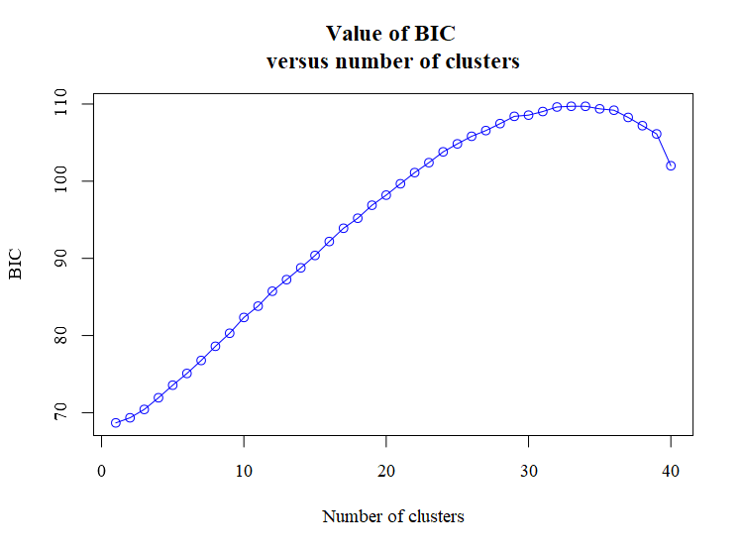
BIC Plot showing the lowest value is one, supporting a single cluster in the DAPC analysis.

Mantel Test of Isolation by Distance.
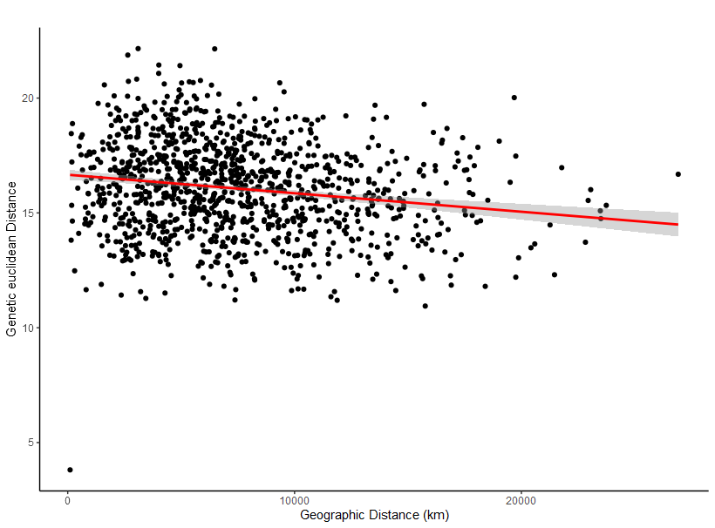
Relationship between geographic distance and Euclidean distances (p = 0.93)

